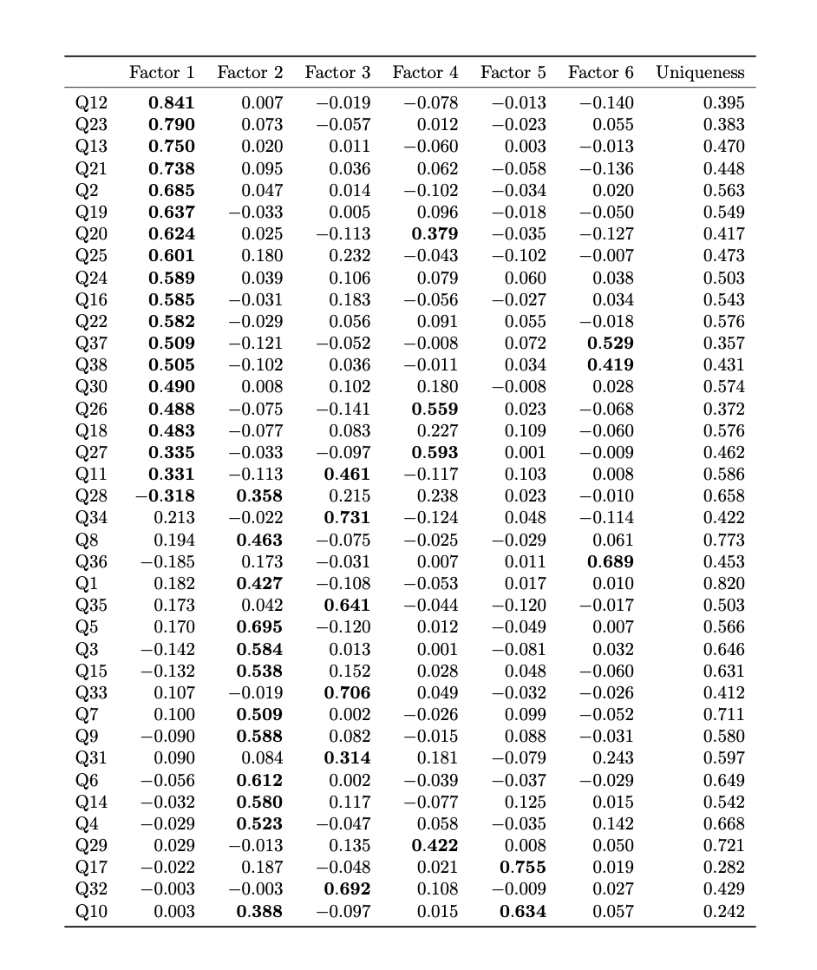
Table 1. Factor loadings of 38 items of the Questionnaire of Unpredictability in Childhood.

Factor | Subscale | Question
1 | Parental predictability | 2: My parents were often late to pick me up (e.g. from school, aftercare or sports).
 | Parental predictability | 11: At least one of my parents had punishments that were unpredictable.
 | Parental predictability | 12: I often wondered whether or not one of my parents would come home at the end of the day.
 | Physical environment | 13: There were often people coming and going in my house that I did not expect to be there.
 | Parental predictability | 16: At least one of my parents would plan something for the family, but then not follow through with the plan.
 | Parental environment | 18: There was a long period of time when I didn’t see one of my parents (e.g. military deployment, jail time, custody arrangements).
 | Parental environment | 19: I experienced changes in my custody arrangement.
 | Physical environment | 20: I moved frequently.
 | Parental environment | 21: At least one of my parents changed jobs frequently.
 | Parental environment | 22: There were times when one of my parents was unemployed and couldn’t find a job even though he/she wanted one.
 | Safety and security | 23: There was a period of time when I often worried that I was not going to have enough food to eat.
 | Safety and security | 24: There was a period of time when I often worried that my family would not have enough money to pay for necessities like clothing or bills.
 | Safety and security | 25: There was a period of time when I did not feel safe in my home.
 | Physical environment | 26: I changed schools frequently.
 | Physical environment | 27: I changed schools mid-year.
 | Parental environment | 28: My parents had a stable relationship with each other.
 | Parental environment | 30: At least one of my parents had many romantic partners.
 | Physical environment | 37: I lived in a cluttered house (e.g., piles of stuff everywhere).
 | Physical environment | 38: In my house things I needed were often misplaced so that I could not find them.
2 | Parental monitoring and involvement | 1: I had a set morning routine on school days (i.e., I usually did the same thing each day to get ready).
 | Parental monitoring and involvement | 3: My parents kept track of what I ate (e.g., made sure that I didn’t skip meals or tried to make sure I ate healthy food).
 | Parental monitoring and involvement | 4: My family ate a meal together most days.
 | Parental monitoring and involvement | 5: My parents tried to make sure I got a good night's sleep (e.g., I had a regular bed time, my parents checked to make sure I went to sleep).
 | Parental monitoring and involvement | 6: I had a bedtime routine (e.g., my parents tucked me in, my parents read me a book, I took a bath).
 | Parental monitoring and involvement | 7: In my afterschool or free time hours at least one of my parents knew what I was doing.
 | Parental predictability | 8: I usually knew when my parents were going to be home.
 | Parental monitoring and involvement | 9: At least one of my parents regularly checked that I did my homework.
 | Parental monitoring and involvement | 10: At least one of my parents regularly kept track of my school progress.
 | Parental monitoring and involvement | 14: At least one parent made time each day to see how I was doing.
 | Parental predictability | 15: My family planned activities to do together.
 | Parental environment | 28: My parents had a stable relationship with each other.
3 | Parental predictability | 11: At least one of my parents had punishments that were unpredictable.
 | Parental predictability | 31: At least one of my parents was disorganized.
 | Parental predictability | 32: At least one of my parents was unpredictable.
 | Parental predictability | 33: For at least one of my parents, when they were upset I did not know how they would act.
 | Parental predictability | 34: One of my parents could go from calm to furious in an instant.
 | Parental predictability | 35: One of my parents could go from calm to stressed or nervous in an instant.
4 | Physical environment | 20: I moved frequently.
 | Physical environment | 26: I changed schools frequently.
 | Physical environment | 27: I changed schools mid-year.
 | Parental environment | 29: My parents got divorced.
5 | Parental monitoring and involvement | 10: At least one of my parents regularly kept track of my school progress.
 | Parental predictability | 17: My family had holiday traditions that we did every year (e.g., cooking a special food at a particular time of year/decorate the house the same way).
6 | Physical environment | 36: I lived in a clean house.
 | Physical environment | 37: I lived in a cluttered house (e.g., piles of stuff everywhere).
 | Physical environment | 38: In my house things I needed were often misplaced so that I could not find them.

Table 2. List of specific items for each factor. Items with factor loadings of 3 or above are included for each factor.

